库存：

1. Skeleton
2. 老虎 Feline_Warrior

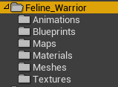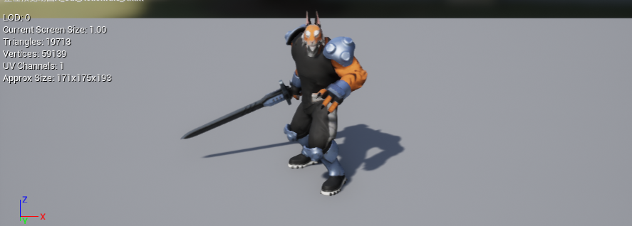

1. 猫CuteKitten

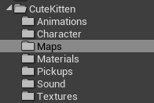

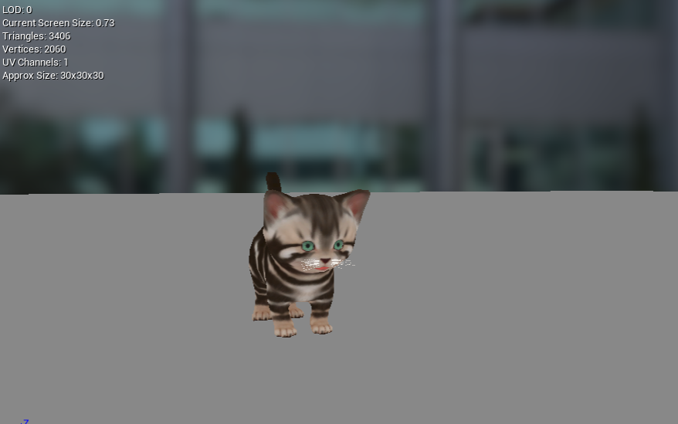

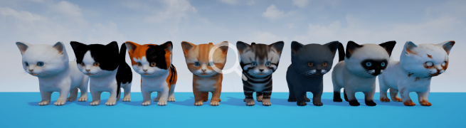

1. 帽子HatPack2

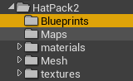

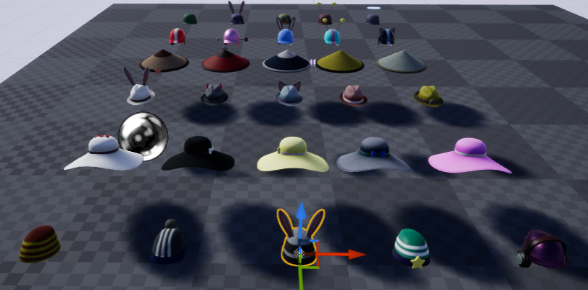

1. Music
2. 冒险音乐 AdventureGameMusicPack



1. Mesh
2. 财宝LootSet

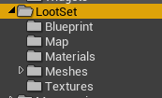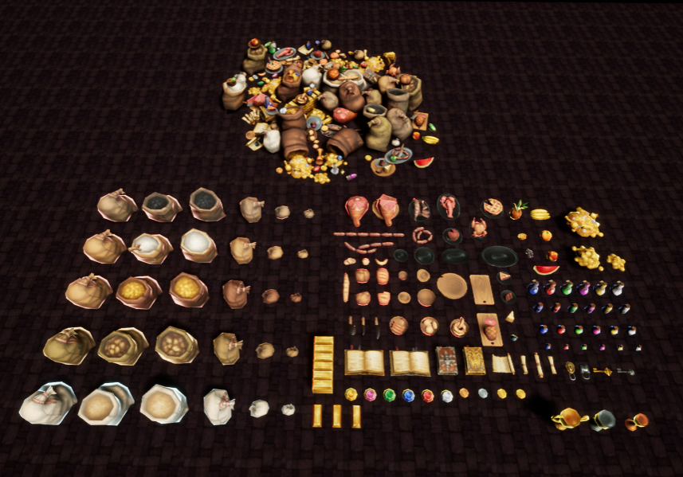

1. 像素冒险PolygonAdventure

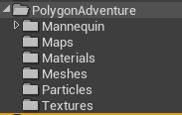

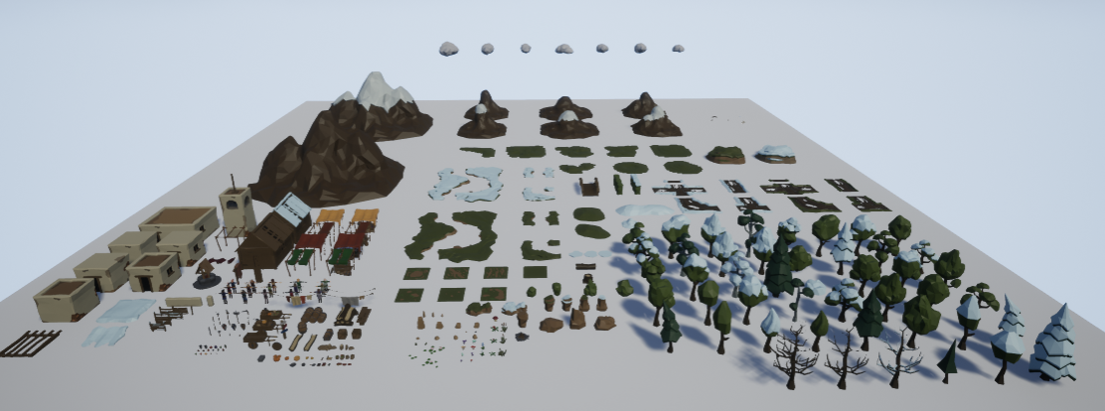

1. 像素骑士PolygonKnights

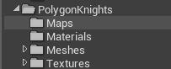

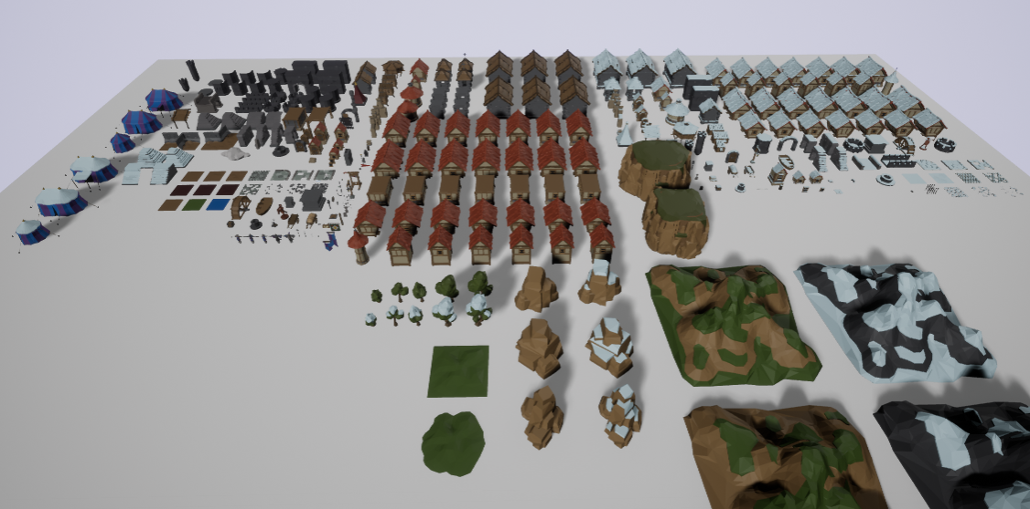

1. 像素房间摆设PolygonKnights

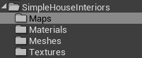

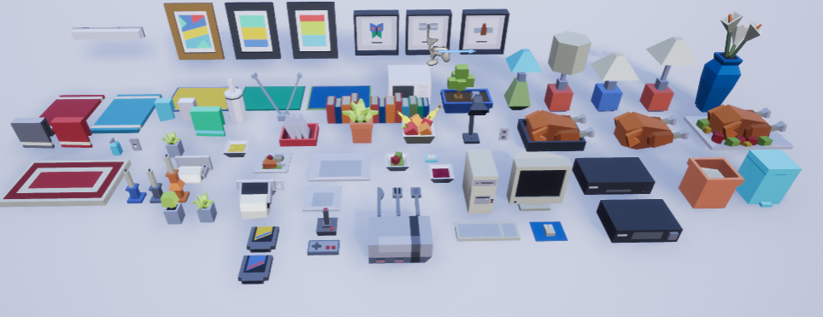

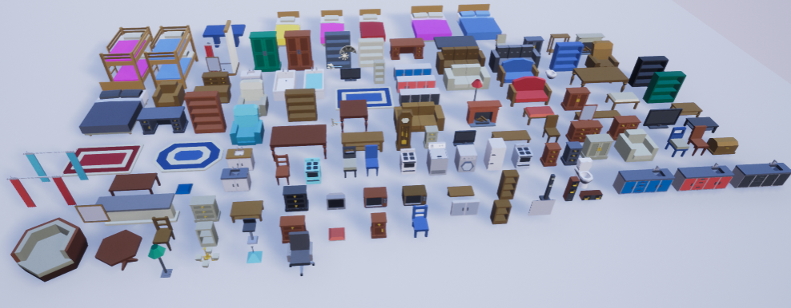

1. 像素城堡摆设SimpleMedievalInteriors

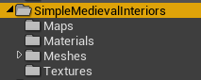

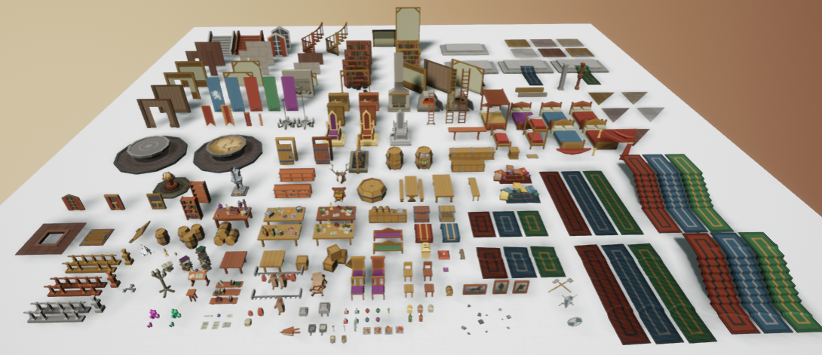

1. 像素办公室摆设SimpleOffice

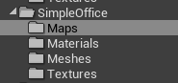

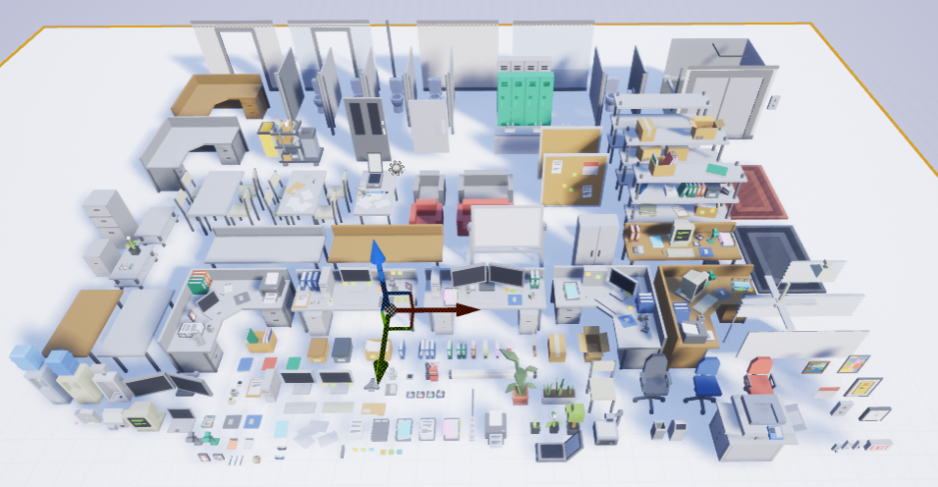

1. 像素玛雅神庙SimpleTemple

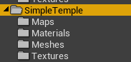

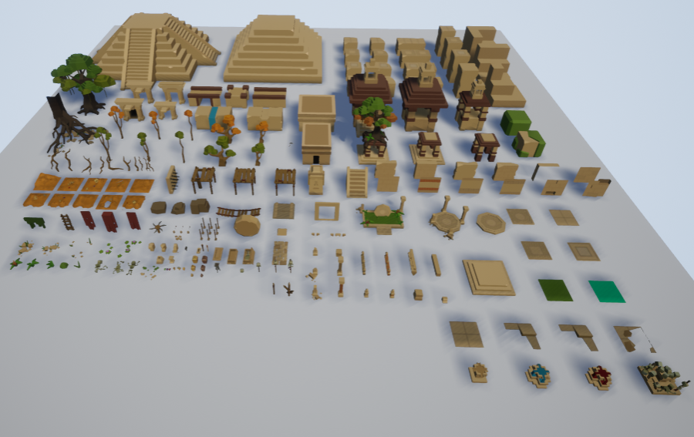

1. Texture
2. 嘻哈贴图GUIPack

